1) Watch ansible-01 video and write down notes.

2) Setup one master and two worker nodes in ansible.

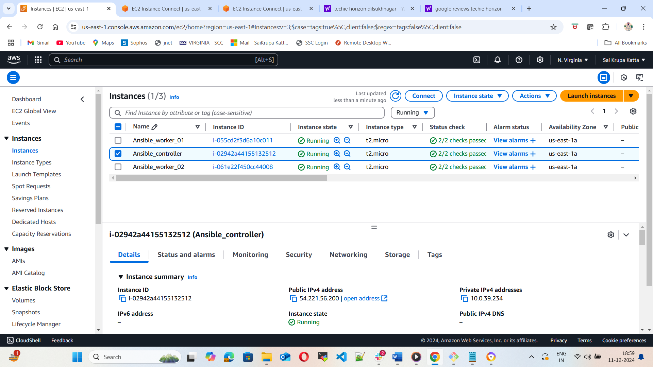

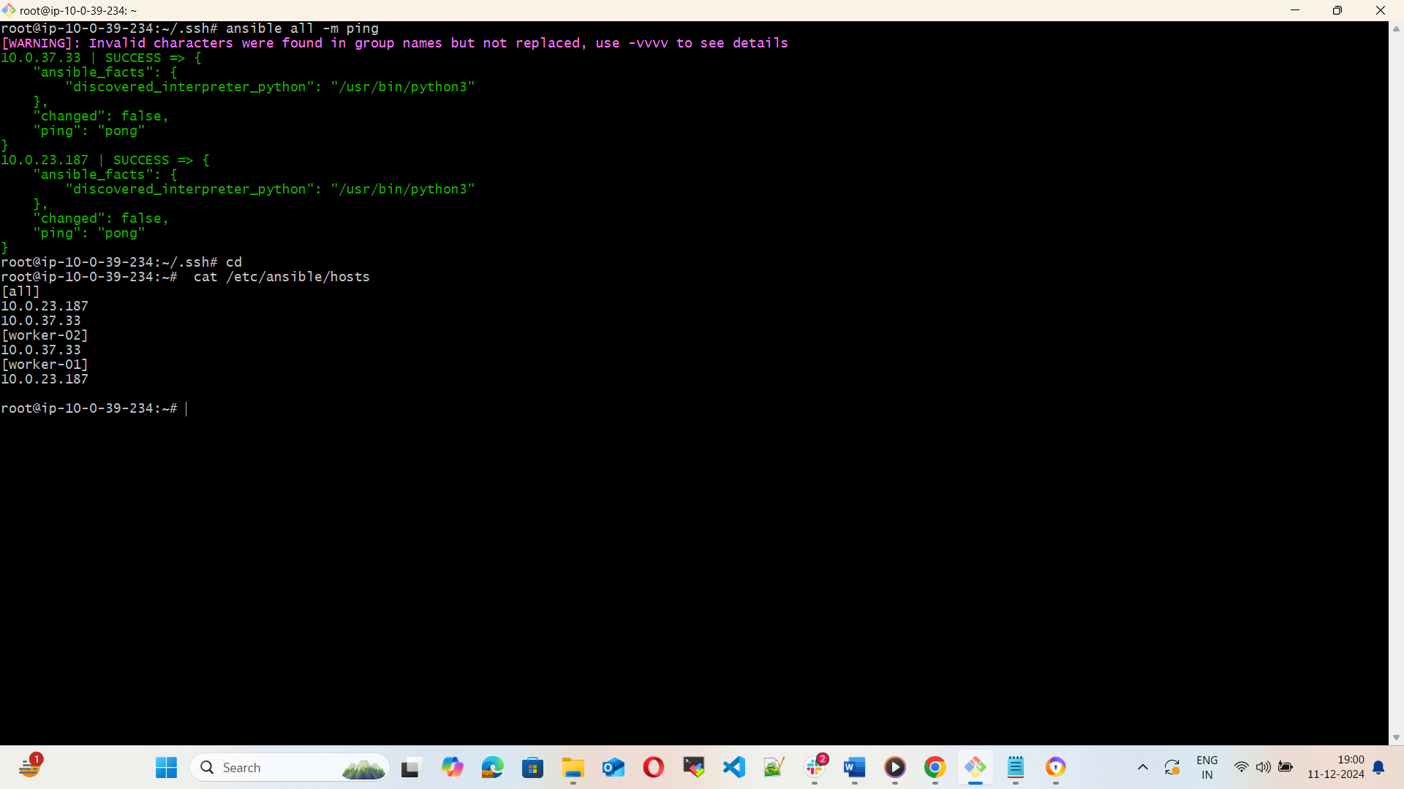

3) Execute the adhoc command shared in #dvps-cloud-documents Channel.

